ASSESSMENT 2 – STEP 3

So before I started looking at my ratios in more depth, I realised I needed to go back and do a lot more research about my company and the market it is in. I hadn’t fully committed to Infomedia in the first assignment and to be able to complete the second assessment to its full potential, I needed a knowledge boost! In turn, this was all very useful in helping me understand the numbers and gave me an idea of why there was a change in the patterns at times.

Something that did alert me when I was researching was that in the 2020 annual report, Infomedia openly talk about planning for the medium term but there is no mention of long term plans. I immediately saw a red flag as surely in the height of a global pandemic, you should be reassuring your investors, not telling them you only have plans for the next 5 years? This does concern me as the sales as a service market is ever evolving as technology moves forward and if they want to grow their market share, surely you need to have confident investors backing you?

I’ll give Infomedia their due, they reacted really quickly to the pandemic and in late March 2020 they put into place a ‘protect and attack’ strategy.

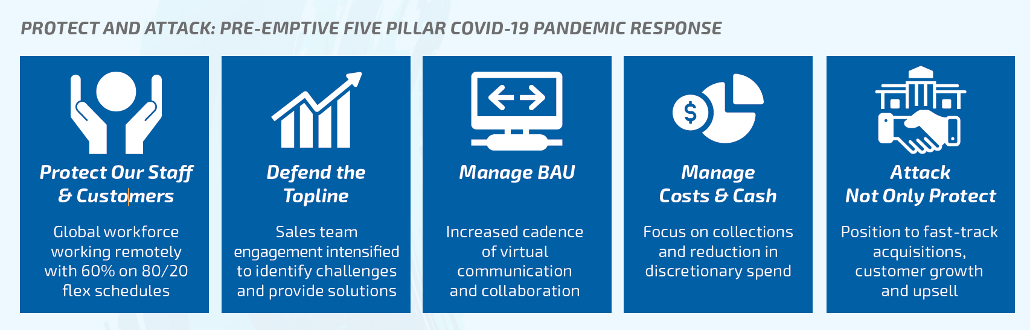
Infomedia chose to help their customers where needed during the pandemic, delaying contract start dates and delaying payments if needed. They also state that they wanted to take advantage of opportunities as they emerged with regards to increasing their assets, are they waiting for someone to fail and grab a bargain? As the new car market was decreasing due to covid-19, their customers changed their focus to aftersales, as Infomedia already have software programs in place to deal with quoting service prices, data analytics and business insights for the aftersales parts and service sector, they could easily adapt.

What do my ratios tell me?

It was clear when looking at my ratios that something big happened in the 2020 financial year apart from a global pandemic as the assets of the company increased significantly. That something was a share purchase plan and institutional placement in May 2020, gaining the company $83.9 million. As this was towards the end of the financial year, they clearly hadn’t had time to use the equity as they intended so it caused a major uplift in any ratios that had anything to do with financial assets. As I knew this was the case, I decided to work out my 2020 figures without the $83.9 million to give me a better picture of where my company actually stands. According to the annual report, the money was raised to enable Infomedia to acquire assets that will leverage core solutions with enhanced technology, gain access to new customers and gain entry into new geographies. I am aware that they have recently purchased an American company ‘SimplePart’ who implement and manage consumer facing e-commerce programs in the US and Canada for a lot of the world’s top automakers to hopefully help them increase their sales in the Americas as this was their only decreasing market in the FY2020. This is definitely a market they need to grow in with the Americas being the second largest car market in the world behind China (Statista, April 2021).
Liquidity ratios are easy to explain and understand, it tells us can our company pay its short term debts. The simple answer is generally yes, although in 2019, ratio 2 drops to 0.91 when you take out the receivables. With the money raised in 2020, the ratios obviously jump to above 5 and again, the only ratio that remains below 1 is quick ratio 2 where we take out receivables as well as inventory (infomedia doesn’t have inventory) and prepayments with it dropping further to 0.72. They seem to be coming more and more dependable on receivables to pay their debts. Surely this is a bad thing? When I look into this, in 2019, Infomedia have signed a lease for a new head office in Melbourne but won’t be moving into the building until the following financial year, they are currently paying rent on two buildings so this will have increased the prepayments. In 4 years they have almost halved their quick ratio 2 result, are they starting to struggle to pay their short term debts?
Infomedia have been debt free for the last 4 years which is a positive to me but have been paying interest in 2020? When I try to explore why they started paying interest in 2020, all that the annual report tells me is that the costs are attributable to qualifying assets and are capitalised as part of the asset whilst all other finance costs are expensed in the period in which they occur. That doesn’t really help me. Has the impact of covid in 2020 affected their liquidity ratios? I believe so, they are happy to inform shareholders that in 2020 when the pandemic broke out, they asked their customers what they could do to help which included deferring payments for a period and delaying contract roll outs. To me, a forward thinking move as generally, if you look after your customers, they stay loyal in the future but why did the figures start to drop in 2019?
The net profit margin has steadily risen from 16.2% in 2017 to 19.6% in 2019 but had a slight dip in 2020 to 18.8% with the funds raised taken out. They do admit in their annual report that covid did hit them in the last couple of months of the financial year as they adopted the practice of how to help their customers by offering to defer payments and delaying the starting of contracts due to the world being put in lockdown due to the pandemic and people not using their cars as much and not having the money to service and repair cars. The slight dip doesn’t concern me and when I look into the half year annual report for FY2021, they are in a similar position as they were at the half-way point last year. They have moved their focus to aftersales as this is the most profitable area for not only themselves but their customers, the dealerships and also started looking at data analytics for dealerships.
So let’s look at total asset turnover, it measures the efficiency with which a company uses its assets to produce its sales. Obviously with the $83.9 million left in the figures, there is a massive dip in the trend from 1.05 in 2017, 0.92 in 2018, 0.92 in 2019 and 0.49 in 2020. But taken out, the trend is a lot steadier staying at 0.92 for the third year in a row. So for every dollar in total assets they are generating they are currently getting back less than a dollar in sales, should this concern me? I look at what they have done in 2020, especially with the pandemic where all of their 400 workforce started to work from home. That’s 400 computers, 400 telephones and headsets, 400 desks and chairs plus I’m guessing other items too. That explains the increase in assets. When I compare these figures to the other companies in my class, Lycopodium (Sam) and Galliford Try Holdings (Emily), they are lower although none really have a pattern. Galliford Try’s jumps in 2020 like Infomedia to 1.79 after being 0.87 in 2017, 1.01 in 2018 and 1.01 in 2019. Emily tells me it was due to them selling off one the companies it owns, Liden Homes and is now focusing on more government contract based builds such as schools, health centres and infrastructure. With regards to the current asset turnover, this again was steadily increasing from 2.84 in 2017 to 3.01 in 2018, 3.21 in 2019 and 3.26 in 2020 (when you take out the $83.9 million). Although the sales and current assets increased again in 2020, they clearly didn’t hit what they were expecting to before the pandemic. Lycopodiums current asset turnover ratio has decreased from 1.70 in 2017 to 1.47 in 2019 and saw a small increase in 2020 to 1.54. Infomedia’s return on net operating assets (RNOA) again saw a steady increase from 30.61% in 2017, 32,36% in 2018, 35.07% in 2019 with a dip in 2020 to 32.55 due to delayed income brought on by the pandemic, although they are all still above 30% which is a really healthy return. When I compare these figures to Galliford Try, theirs are much lower 6%, 13%, 9% then jumping to 25% in 2020. Clearly selling of Linden homes was a positive move for them when it came to reducing assets and increasing returns. When I look at Lycopodium, theirs is all over the place! -73%, 210%, 72% then -42%. When I speak to Sam about it further, they had negative NOA in 2017 and 2020 and a lot lower OI. This was due to them being paid out in advance for contracts and as they are a company that is in the mining industry, their costs will have continued throughout the length of the contract decreasing the assets.
Debt to equity ratio is an important one for me, they have less that 50% each year, 34.4% in 2017, 46.8% in 2018, 43.9% in 2019 and 24.6% in 2020 which is a positive. When you take out the $83.9 million in 2020, it rises to 58.4% so is on an upward trend but with increased outstanding receivables, my prediction is that this will drop again in 2021. When I compare it to Galliford Try, theirs is huge with the lowest year being 273%!! They clearly rely on their income to pay off their liabilities, I’m not sure that makes me feel good about them, what if one of the companies they are working for goes into liquidation and they can’t get their money back? Maybe that is why they have decided to work on mainly government contracts now, at least you know you will get paid. From an investment point of view, Infomedia and Galliford Try are definitely more appealing from this ratio than Lycopodium or maybe that’s because I’m a girl who likes consistency?
Overall, I believe that Infomedia is performing well in what is a tough economy worldwide at the moment. They are still expanding and looking to increase their market share. My worries are that there is little talk about how they are going to evolve when the car market changes to mainly electric vehicles. These vehicles don’t need as much servicing and some automotive companies are talking about selling direct, cutting out the dealership completely. What are their plans to survive this huge curveball?

The link to my blog post on my ratios is https://karenthepom.home.blog/2021/06/03/ratio-o-ratio-where-for-art-thou-ratio/

Blog Comments on Ratios

So I looked at Christies blog as on the company spreadsheet it said she was in the automotive industry so I was looking for trends as our industries are related. When I looked into the company, it has nothing to do with the automotive industry, they are an engineering firm!
https://cjsmithmatureagestudent.wordpress.com/2021/05/30/step-3-ratios-what-the/comment-page-1/?unapproved=5&moderation-hash=50d2220c33747a232d571555adabca71#comment-5

My next blog I looked at was Tricia Stanley who had Motorcycle Holdings. Although not in the car automotive industry, they are in the Motorcycle industry and I wondered if their trends were similar.
https://island244719113.wordpress.com/2021/05/30/key-accounting-drivers/comment-page-1/?unapproved=43&moderation-hash=ab1fc87626142f425c2da0d7f88db5eb#comment-43

My final blog I looked at was Leigh Scherner. Leigh has Jumbo Interactive who were my company in ACCT11059 back in my first term at CQU. Now I’m in my final term, I wanted to have a look to see if the positive trends the company had back then were continuing for old times’ sake (insert smiley emoji).
https://leighsfreshst.art.blog/2021/05/28/the-final-valuation/comment-page-1/?unapproved=56&moderation-hash=e5e91c268c89b6033d6cc5045a0993bc#comment-56

Accounting Drivers

Return on Net Operating Assets (RNOA) – Operating income has steadily grown over the four years from $70,330 in 2017 to $96,058 in 2020 but net operating assets have grown at a faster pace being $37,248 in 2017 to $56,354 in 2020. I know that in 2020 the NOA increased due to having all the staff working from home and having to supply them with the equipment needed, a good investment in my eyes as over 12 months down the line, the pandemic still has a hold over the world. In 2019, the NOA increased by over $8 million, when I look into this, I find that the capitalised development costs had increased significantly by $19 million. This is due to the development of a huge update on the company’s core products Microcat electronic parts catalogue and Super service solutions. These updates were both launched in the 2020 financial year. The right of use assets which move to intangibles in 2019 due to a change in accounting standards increases year on year from $40,253 in 2017, $53,693 in 2018, $64,355 in 2019 and $67,898 in 2020. Although they have improved the software, how does it increase in value? When I think about the software subscription, I compare it to Microsoft software packages, the more people that use it, the more valuable it becomes, I’m guessing the same goes for Infomedias software packages. As their customer base is building, the software becomes more valuable.
Profit Margin – PM is made up of net profit after tax or operating income (OI) divided into sales. Even with the impact of covid, they still increased both OI and sales in 2020 to $18,345 and $96,058 respectfully, although the PM did drop in 2020 to 18.8% . This doesn’t concern me as the drop is less than a percent and they are very open to telling the share-holders why this is. The growth rate is steadily increasing from 16.2% in 2017 to 19.6% in 2019 and the numbers are still in a really good position considering the events of the last twelve months.
Asset Turnover – ATO is total sales divided by net operating assets. Again, both the total sales and net operating assets have grown over the four year period although the asset turnover has decreased year on year from 1.89 in 2017, 1.75 in 2018, 1.71 in 2019 and 1.68 in 2020. Again, the only thing that stands out to make this happen is the increase in value of the software packages that they own and rent out to their customers. Comparing these to Lycopodium, they have absolutely no pattern, -16.67, 23.22, 7.08 and -9.18, and Galliford Try who do have a pattern,3.18, 3.01, 2.69 and then jumping to 88.59. This is due to selling off Linden Homes and massively reducing their operating assets.
Free Cash Flow – FCF is the operating income (OI) less the change in net operating assets (NOA). Again this grows at a steady pace from $9,060.19 in 2018 to $9,612.97 in 2019 and then jumps to $11,367.90 in 2020. The only thing that stands out in NOA is the jump in trade and other receivables in 2020 to $12,055 but this is due to them deferring payments due from customers and delaying the start of contracts. They know the money is coming and to me they are doing the right thing ethically. Comparing this to Galliford Try, their FCF is negative in 2017 at -9.68 then jumps to 54.97 in 2019 and then skyrockets in 2020 to 1311.32. Lycopodium also has a similar pattern being -3,759,041 in 2017 then going positive 2,423,109 in 2019 and skyrocketing to 53,450,272 in 2020. These comparison companies that Emily and Sam have are making my financial statements look boring!!
Economic profit or abnormal operating income is driven by NOA, cost of capital (WACC) and RNOA. When I look at the individual annual reports for each year, I find that the cost of capital used has varied each year and also varied depending on the different sectors of the global market.

 | 2017 | 2018 | 2019 | 2020
Asia Pacific | 11.5% | 10% | 11% | 11%
EMEA | 10.5% | 10.5% | 10.5% | 10.5%
Americas | 10.8% | 10.5% | 10.5% | 10.5%

So why would they have different WACC figures for different markets? To me it is because in different countries, things have different values. What a dollar can buy you in Australia is a lot less than what a dollar can buy you in say Thailand. If companies kept their prices the same across all of the worlds markets, they would not succeed in every market. The Asia Pacific market is the largest part of Infomedias market at 30.7% of overall sales, this was also their market with the largest growth from 2019 to 2020 with a growth of 27%. The RNOA is comfortably above the WACC figures each year being 30.61% in 2017, 32.36% in 2018, 35.07% in 2019 and 32.55% in 2020. This is good to read especially when I compare it to Galliford Try where Emily was using a WACC of 8%. In 2017 their RNOA was 0.06 and only in 2020 did it rise higher than the WACC at 25.01%. Again Lycopodium’s RNOA was all over the place, -73.0% in 2017, 210.4% in 2018, 72.6% in 2019 and -42.6% in 2020. With Galliford Try, you can see that they have had a restructure, selling off part of its business and this has had a positive effect on their financials. With Lycopodium, the figures go from one extreme to another and to me would only appeal to the high risk investor. I understand that you should expect to make losses maybe every 3 or 4 years in 20 but although their PM is positive, there is just too much inconsistency once you delve deeper.

Blog Comments Accounting Drivers

Most of my discussion with regards to accounting drivers and the overall subject was done in our weekly workshops with Lois, Sam and Emily. I got so much information from my fellow classmates guided by Lois and I find it easier to discuss in that environment than on the blogs as you can get any queries answered. As much as I enjoy blogging and reading other people’s blog, I prefer face to face as you can get more in depth information.

https://wordpress.com/read/feeds/68563565/posts/3373767016
https://wordpress.com/read/feeds/114908007/posts/3366404359

Step 4 - Economic and Business Drivers

So looking at the economic profit over the last four years, it has increased year on year from $8,423 in 2017, $10,154 in 2018, £13,364 in 2019 and $13,837 in 2020. The free cash flow has also grown steadily from $9060 in 2018, $9,612 in 2019 and $11,367 in 2020. The RNOA is consistently above 30%, a great position to be in and the ATO is well above 1.5 each year. Profit margins are also healthy and I read from this that they have had a successful period in the last four years and are in a good position moving forward.

So what challenges lie ahead for the automotive sales as a service sector? What are Infomedia doing to keep up with the market and what plans do they have in place to keep growing in an ever evolving market. In the Annual presentation, they have the following slide telling shareholders and potential investors that they are positioned for industry disruption:
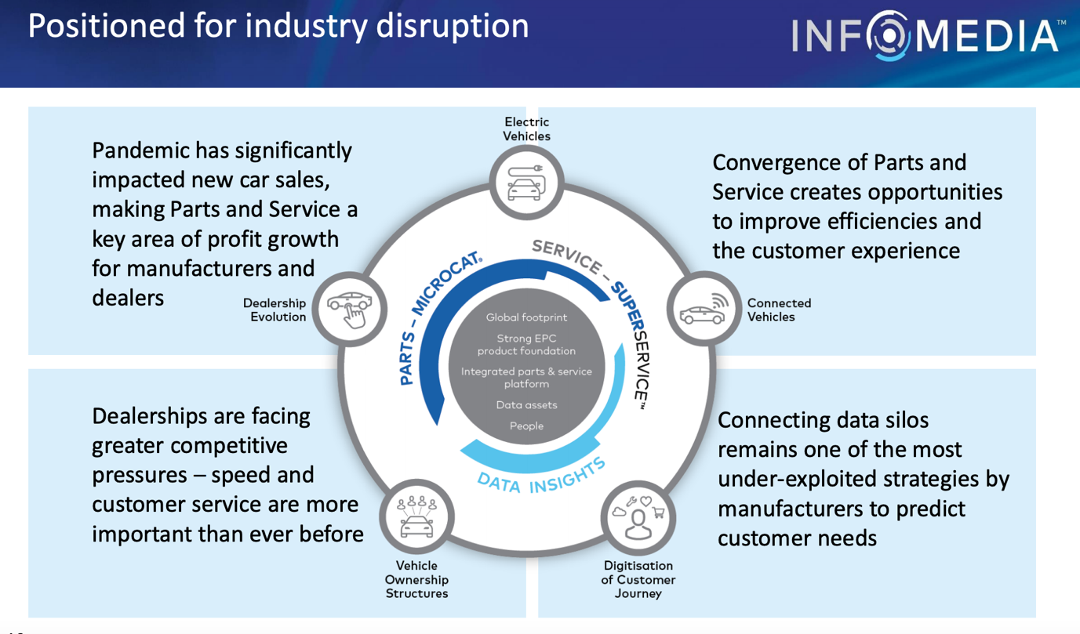
I have read through every article available on the website and I cannot find any more in depth information than this. Are they being clever and keeping their cards close to their chest? It is a competitive market and you have to be the first person to launch a product. Just like Microsoft Office, it was the first software package of it type ever released, nobody since has come anywhere close to getting the share of the market they have. When I have researched on the internet what changes are coming to the automotive industry, they match what Infomedia are reporting on above with the exception of emissions regulations although this is related to electric cars that have zero emissions.

ELECTRIC VEHICLE MARKET

The electric car market saw a 40% increase from 2018 to 2019 with over 2.1 million electric vehicles being sold in 2019 bringing the number of electric vehicles on the roads to 7.2 million with 47% of these being in China, the world’s largest car market (IEA 2020). This is clearly the way that the car market is going and although Infomedia says it has plans in place to deal with the movement, it doesn’t tell us what. Electric cars need less maintenance and have fewer parts so this is not a good sign for Infomedia (AFDC, 2021).

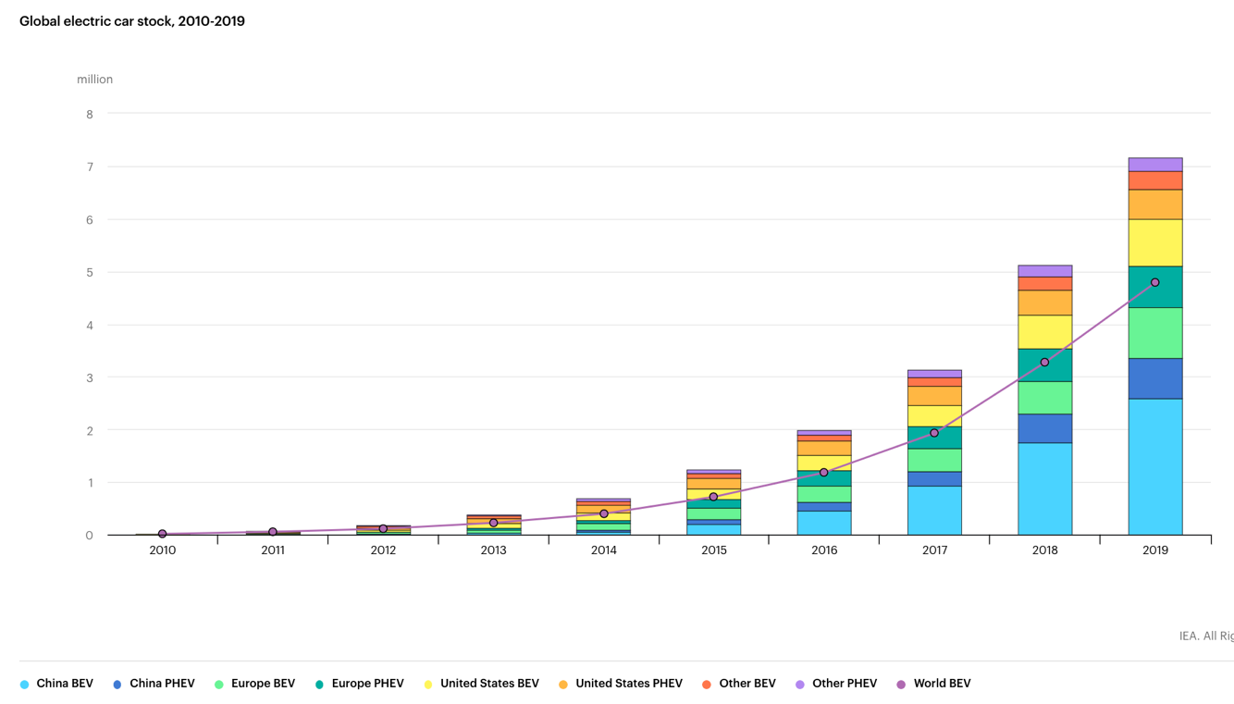
https://www.iea.org/reports/global-ev-outlook-2020

VEHICLE OWNERSHIP STRUCTURE
Many people who live in cities are moving away from owning vehicles due to increased costs such as parking, congestion fees and toll fees. The lack of parking in major cities across the world is also an ongoing issue. Shared car facilities have been around for a few years and are becoming more popular but PWC predict that with the introduction of autonomous vehicles in the future, you will be able to order cars to come to you. Trails have already started and according to the New Your Times they will be available in limited areas on limited streets. Elon Musk on the other hand is saying that we should expect to see these cars in 2021, that’s this year!

ZERO EMMISIONS MANDATE/ FUEL ECONOMY STANDARDS

Many counties around the world already have legislation or are in the process of putting legislation in place with regards to zero emissions and target dates.
Although not on the list below, China has the target of 40% of car sales to be electric by 2030 and America currently has a bill going through to have zero emissions by 2040. Australia is yet to even have a target in place although Scott Morrison is under building pressure to do something about this.
Brazil, China, Canada, European Union, India, Japan, Mexico, South Korea and the United States have all established or proposed fuel economy/ emission standards for vehicles. This covers over 80% of the global market (ICCT, 2021)
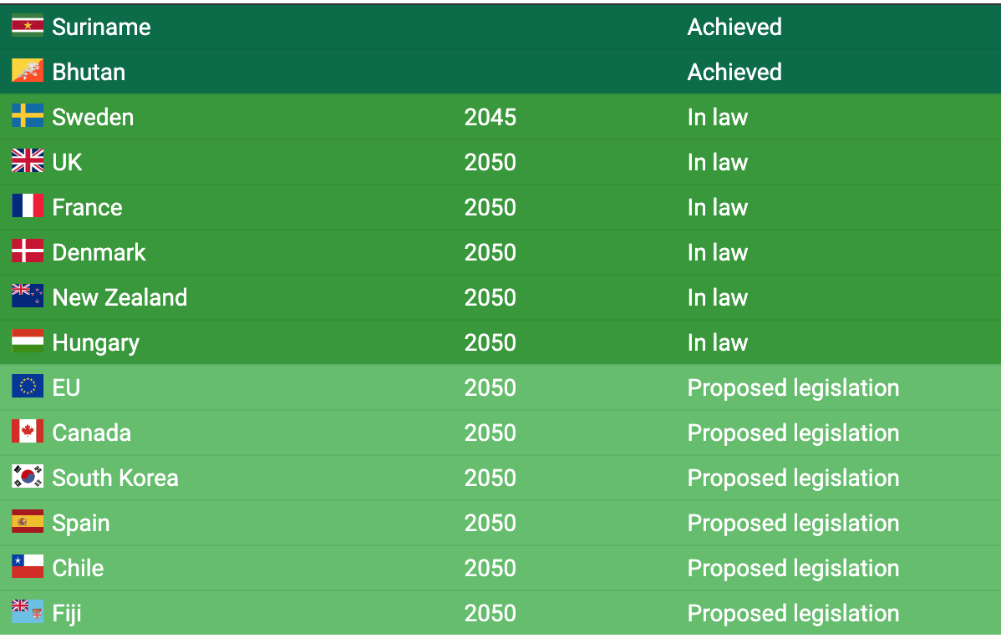 https://theconversation.com/5-years-after-paris-how-countries-climate-policies-match-up-to-their-promises-and-whos-aiming-for-net-zero-emissions-151722

Infomedia say they have adapted to move with the changing market as connected, autonomous and electric vehicle sales increase and quote that these emerging trends are resulting in an increased focus by manufacturers and dealerships on leveraging technology in automotive aftersales and that the software that they offer can increase aftersales profitability, improve service levels and capture and retain customer insight, that will be the data analysis software that they have introduced.

I do know that infomedia are wanting to increase their market share, hence the share plan to gain funds to do this and this may be successful short term but unless they have the right strategies and plans in place to be viable in the long term, I’m not sure that they area good investment.

STEP 5 – FORECASTING AND RATIO COMMENTARY

When I look at my company compared to others, I feel that it is lacking drama in its financial statements and that the results have gone along swimmingly for the last four years. I mean, I’m not a fan of drama, I much prefer stress free situations but my results are pretty straight forward if you remove the share purchase plan gains. This money is to be used to invest in asset that can help build the size of the company in the industry and grow their customer base.
I feel that over the next 5 years, they aren’t going to be affected too much by the move to electric cars as although the amount being sold each year is increasing, it is still a small share of the market with out of the 86 million new cars sold worldwide last year, only 2.08 million of these were electric or hybrid. That’s less than 2.5% of the overall market although it is growing each year and is expected to hit 7% of overall car sales in 2021 taking the number on the road to over 5 million, I don’t think it will have a dramatic impact over the next 5 years. Although it will over the horizon.
With regards to sales increase, the company believe that they can hit the projected $200 million of revenue by 2025, I don’t share their expectations with the pandemic still holding the majority of the world in lockdown with no clear idea when borders will open, I can’t realistically see this happening unless they use the funds raised to invest in successful businesses that will help them do this. They have recently purchase Simplepart who’s annual revenue in 2020 was $10.16 million AUD that increase in revenue leaves them short of getting them to their $200 million target. I understand that they don’t need to travel to get their business to work for them, but with the motor industry struggling during the pandemic and no sign of recovery, this will affect them and will they be able to recover in time for when the electric car market impacts car sales significantly? I feel that I am doubting the ability of the company as they aren’t telling us a lot about their strategy for the future. They are fully aware of what the disruptions to the industry will be, but they don’t tell us what they are planning on doing to counteract these disruptions.
Looking at the share price performance over the last 12 months, it isn’t positive reading for Infomedia. The share price fell drastically on the 26th February from 1.8 to 1.51 which was 2 days after the dividends announcement. It fell even further on 4th March when Wilson Asset Management Group (WAM) announced they were selling their shares in Infomedia. They held over 11 million shares having a 3.4% stake in the company. Then again on the 26th March, Viburnum Funds Pty Ltd sold their stake of 3.4% or over 11 million shares in Informedia. This made me wonder why these companies were pulling out, what do they know that we don’t? I haven’t heard of either of these companies so I decided to research them. Wilson Asset Management Group invest in undervalued growth companies, does this mean that they feel Infomedia has made its money and isn’t going to achieve anymore growth? Viburnum Funds Pty Ltd are also an investment company, do they no longer see Infomedia as a wise investment choice? Surely these experts know better than me? It dipped again this year in May when they announced that the CFO Richard Leon was leaving the company, this clearly had an impact and since this announcement, the value of the shares has fluctuated significantly.
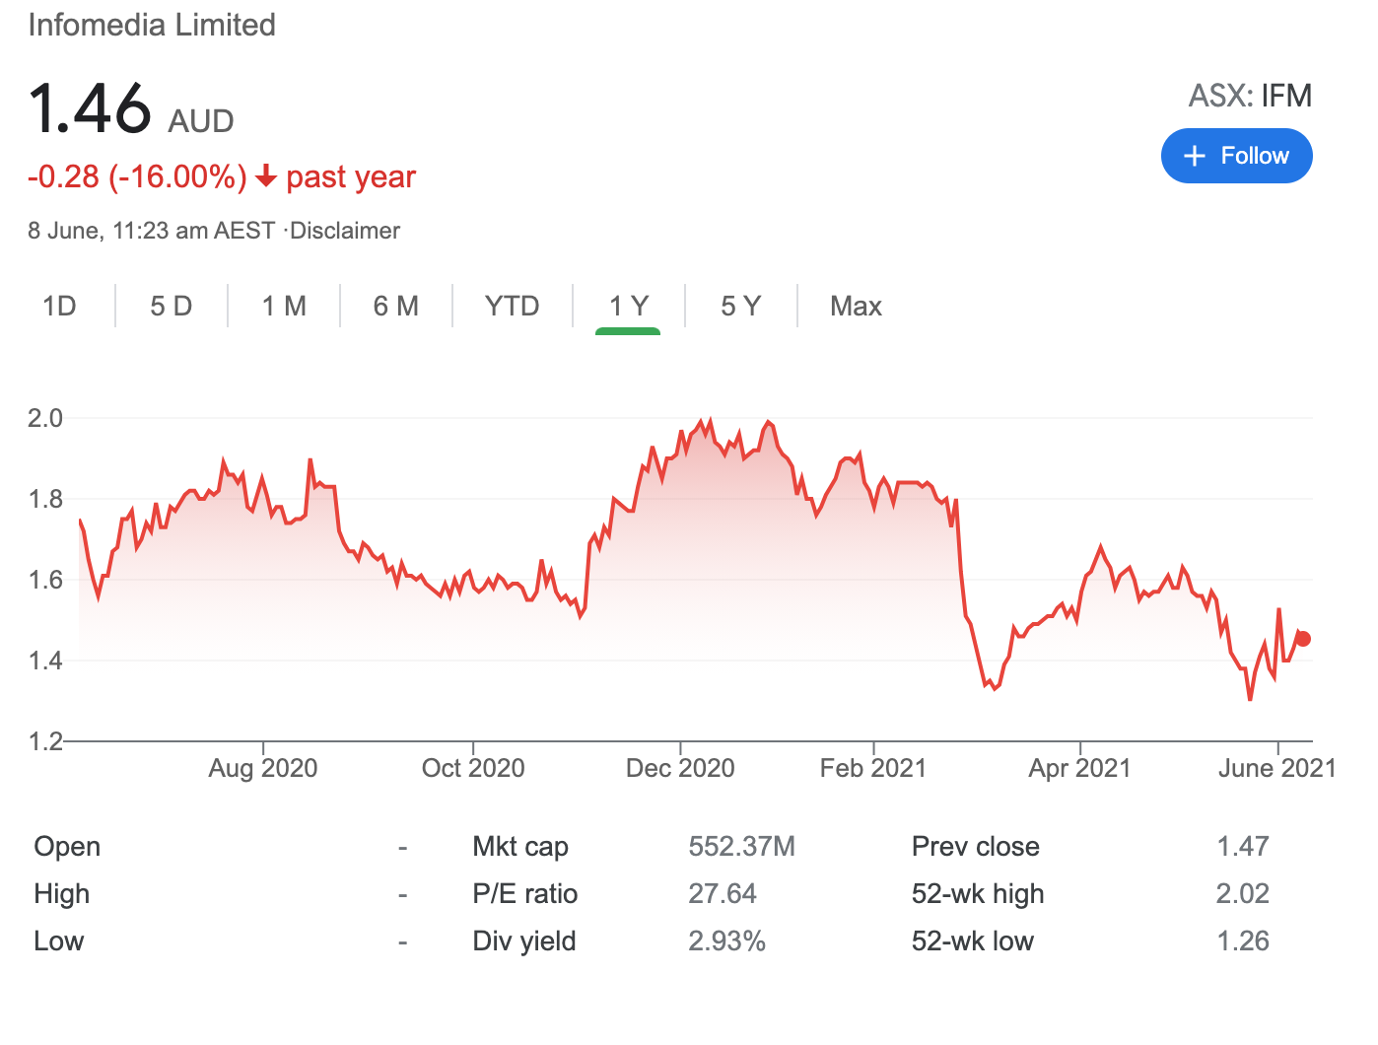
Does this help me project where I believe my company will be over the next five years? One thing I do know is that I won’t be projecting for big growth, if anything, I feel I should project for sales growth to continue growing albeit at a similar pace. I feel

KEY ASPECTS OF FORECASTS

SALES GROWTH
I believe that sales will continue to grow at a similar rate in 2021 to 2020 and they will increase from then on as the company invests the money raised in buying smaller companies in the sector like they have done with Simplepart. I do not think that they will reach their target of having $200 million sales in the 2025 financial year.

PROFIT MARGIN
I believe that the profit margin will grow slightly each year due to the increased customer base from new investments although if they decide to increase research and development to move into the electric car aftersales market, this may reduce but I have not factored this into my projections.

ASSET TURNOVER
With the increase in sales growth and increased profit margin, the ATO will continue to decrease at a slow rate but remains over 1 which is positive.
 | 2021 | 2022 | 2023 | 2024 | 2025
Sales | $106,918 | $121,886 | $140,169 | $162,597 | $188,612
NOA | $66,824 | $78,132 | $93,446 | $111,367 | $129,186
ATO | 1.60 | 1.56 | 1.5 | 1.46 | 1.46

WACC
I have decided to use 11% as this is what the company has been using for its largest market in EMEA this is also its most successful market.

GROWTH RATE
I have gone with 7% as the RNOA is steadily over 30% each of the last 4 years which is over 19% above the company’s WACC. If I put 19% in as my growth figure, it gives me a negative continuing value and a negative enterprise value. If I put it in lower at say 7%, it give me positive values. I’m confused as to why this would be. Are they using a WACC that is too high for them? Surely the company would use a figure that they see is a true reflection and if this figure wasn’t suitable then surely the auditors would pick this up? I’m lost!
They still have over $50 million from the share scheme left and this is still in assets in the half yearly report to invest and increase their market share. I don’t believe that the electric car market is going to affect them in the next 5 years.

In summary, my forecast for Infomedia is based on the sales revenue continuing to grow as the company continues to expand its market share. I believe that in the medium term, they will be successful but will need to adapt for the longer term.

VALUATION
I have forecasted for the company to continue on the protectory that it is currently on with positive sales growth, steady profit margins and asset turnover above 1 although this is decreasing slightly each year.
Using the forecast figures and economic profit valuation spreadsheets, I have arrived at the following values

Enterprise Value | $488,827,750
Number of Ordinary Shares | 326,471,000
Valuation Share Price | $1.50
Market Share Price 8th June 2021 | $1.44

RECOMMENDATION
Although my valuation share price has come in pretty close to the actual share price today, I would not make an investment in Infomedia based on my analysis. I feel currently, especially with the resignation of the CFO, the ship is not very steady, hence why the price has dropped. But on the other hand, would this be the best time to invest in the company whilst the prices are low but the question is will they rise again. I believe that they will once they announce a new CFO but how long this success will last with the pending economic factors I’m not sure.

UNIT LEARNING SUMMARY
I was really looking forward to studying this unit at the beginning of term, I really enjoyed starting my CQU journey in ACCT11059 with Martin and Lois and was glad to be working with both of them in my final term. I have found this term tough, being my final term my study load has increased plus the pressure brought on by myself to finish my degree with a distinction after struggling last year due to the effects that the pandemic had on my personal state of mind and my grades taking a dip.
I really enjoyed studying this unit although I did have to go back briefly and refresh my knowledge with some of the analysis we learnt in 11059. I found ACCT13017 to be eye opening although challenging at times but the reason it was challenging was the fact that I was given a company that I had never heard of in an industry that I didn’t even know existed and if I’m honest, I don’t have any interest in so struggled to get an emotional connection with the firm. Studying something is always easier if you can find that connection.
I am so glad that I am studying on campus, as I have found out discussions about our companies so much easier to do face to face rather than writing a comment on blogs and waiting for a response although I have done this and it is great to see so many names that I recognise from the earlier unit completing this unit alongside me. With participant numbers being low due to matters beyond our control, it has been hard at times to get responses from people. I know at the beginning of term doing peerwise, I would run out of questions each day as I was trying to get ahead. One great thing about this unit is that I have also made friends for life in Emily and Sam and am so excited for Sam and I to graduate together in August as Sam has been with me every term throughout my journey.
So what can I do now that I couldn’t 12 weeks ago? I can tell you the difference between the economic drivers and the accounting drivers of a business and that factors you wouldn’t think would affect a business, will affect a business. You need to ensure that you are fully aware of the economic factors of a business if you are going to have any chance of forecasting the company’s future value. I’ve learnt that even though my forecasting skills are quite impressive (well in this assessment anyway) I still wouldn’t invest my money in the share market myself, I just don’t have the confidence, or the money to lose.
So if I had to co-teach a section of this unit next year what would I pick? I believe that I would chose economic drivers as this is part of the unit that I feel that I have learned the most on and now have a clear view of what economic drivers are compared to accounting drivers. I also think I’d be good at ratios as it is a good way to keep reminding yourself of how to tell if your business is currently successful or not. Obviously I only feel like I could do this well myself as I have been taught well. The difference between having a great lecturer and an average lecturer can be the difference between not only fully understanding and digesting what you are being taught but the difference between a higher distinction and a credit when it comes to grades.
So what advice would I give to students who are going to study this unit in the future? What are the three most important things you should make sure you do to keep your sanity in this unit?
- Time management time management time management, with a bit of planning thrown in. I always start a term with the best intentions, make sure I am well prepped and ready in week one but as the term goes on, things happen that are out of your control (I had to move house in week 10!) but you also get distracted and think you’ll have time to do it tomorrow. I’m telling you now, if you are studying more than one subject and have other responsibilities, I’m doing four and working part time, you need to get it done when you say you are going to do it as the workload as you go through the term gets bigger and bigger and your deadlines get closer and closer.
- Don’t ever be afraid to ask a question, I can guarantee that someone else is wanting to ask it too and you will always get a helping hand without being judged, on the Q&A page on Moodle.
- Write your KCQ’s as you are reading through the chapter to save you time. When I do mine, I have my word document on the left of my screen and the relevant chapter on the left. Also when writing your KCQ’s have a bit of fun! If something that Martin is talking about reminds me of something, I make sure I let him know and thank him for the memories

My blog link with regards to steps 3-5 : https://wordpress.com/post/karenthepom.home.blog/198

References

Alternative Fuels Data Center (2021). Maintenance and safety of hybrid and plug-in electric vehicles. Retrieved from: https://afdc.energy.gov/vehicles/electric_maintenance.html

ICCT, (2021). Chart library: passenger vehicle fuel economy. Retrieved from: https://theicct.org/chart-library-passenger-vehicle-fuel-economy

IEA (June 2020), Global ev outlook 2020. Retrieved from: https://www.iea.org/reports/global-ev-outlook-2020

The Conversation (11 December 2020), 5 years after paris: how countries’ climate policies match up to their promises, and who’s aiming for net zero emissions. Retrieved from: https://theconversation.com/5-years-after-paris-how-countries-climate-policies-match-up-to-their-promises-and-whos-aiming-for-net-zero-emissions-151722

Statista (1 April 2021), Largest automobile markets worldwide in 2020, bases on new car registrations. Retrieved from: https://www.statista.com/statistics/269872/largest-automobile-markets-worldwide-based-on-new-car-registrations/

